1. Introduction
It is our responsibility to provide a safe place of work, to identify any risks or hazards, to put measures in place to minimize these and to ensure the safety of everyone concerned participating in a Northern Ireland Fencing (NIF) activity.

This policy is not contractual but sets out how we plan to manage such issues.

2. Aims of this Policy
• to provide adequate control of the health and safety risks arising from our work activities;
• to consult with our employees on matters affecting their health and safety;
• to provide and maintain safe equipment where issued;
• to ensure safe handling and use of substances;
• to provide information, instruction and supervision for employees;
• to ensure all employees are competent to do their tasks, and to give them adequate training;
• to prevent accidents and cases of work-related ill health;
• to maintain safe and healthy working conditions; and
• to review and revise this policy as necessary at regular intervals.

3. Legal considerations
The following piece of legislation applies:
- Health and Safety at Work (NI) Order 1978.
- The Management of Health and Safety at Work Regulations (Northern Ireland) 2000

4. Employees’ duties
All employees have a duty to take reasonable steps to ensure that they do not place themselves or others at risk of harm. They are also expected to co-operate fully with us in complying with any procedures that we may introduce to protect the safety and well-being of our staff and visitors to any venue being used by Northern Ireland Fencing.

Failure to comply with this policy may be treated as a disciplinary matter.

5. Procedures
We have introduced the following procedures in order to maintain high standards of safety:
• Any employee who is using personal transport for their employment must have a Driving Licence and Insurance to cover the vehicle used and for the purpose used i.e. Insurance for personal business use.
- The vehicle must be roadworthy and if required have a valid MOT and be taxed for road use.
- The employee must at all times comply with the current NI legislation on road use. Failure to do so may be a disciplinary issue as well as a legal one. Any prosecutions including receipt of a fixed penalty notice must be reported to the MD who will treat the matter in strict confidence but will if necessary, refer to other members of the NIF Board if required.
- NIF does not own or rent any premises and out activities are generally in premises owned and managed by external parties. As such the generic risk assessments of those buildings generally suffice. This however does not remove the responsibility from the NIF representatives using these premises to complete a dynamic risk assessment of the premises to ensure there are no obvious risks from the building being inappropriately maintained or the equipment used by NIF introduces a risk such as badly placed or unsecured cables.
  - Step 1 Identify the hazards
  - Step 2 Decide who might be harmed and how
  - Step 3 Evaluate the risks and decide on precautions
  - Step 4 Record your findings and implement them
  - Step 5 Review your assessment and update if necessary
More information can be found at: https://www.hseni.gov.uk/sites/hseni.gov.uk/files/publications/%5Bcurrent-domain%3Amachine-name%5D/five-steps-to-risk-assessment-2017.pdf

- All NIF personnel will on entry to premises being used for NIF purposes familiarize themselves with emergency exits and ensure all persons there on NIF business are aware of the emergency routes out. They will also ensure that they can account for everyone using the premises for NIF purposes both before and after any evacuation procedure whether as part of a planned test or an actual emergency.
- Where issues with the building are noted it is the duty of the NIF personnel present to alert the building supervisors. This duty should not prevent personnel taking immediate safety action to mitigate any risk, if the danger is imminent.
- Where the risk is from activity of the NIF function using the building, NIF personnel will ensure that any risk is mitigated to an acceptable level. An acceptable level is one that the NIF personnel believe acceptable based on their experience and assessed as green on the below Matrix 1.
- NIF personnel shall ensure that any activity is covered by sufficient insurance for the event. British Fencing insurance cover for events has public liability of £10m and is deemed sufficient for any competition run by NIF. Coaching events will also require insurance cover and this is down to the individual coach to provide.
Matrix 1
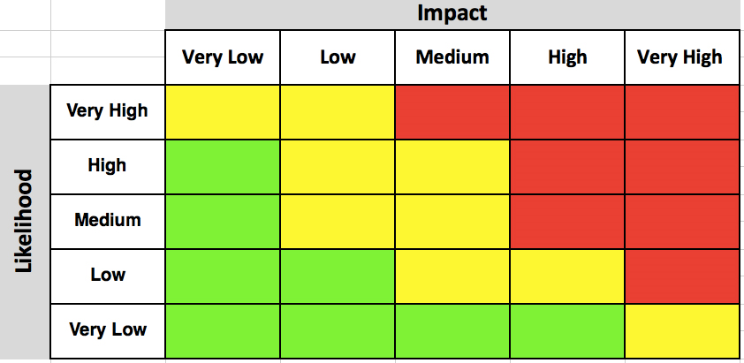
6. Implementation, monitoring and review of this procedure
This procedure will take effect from 1st March 2020. The NIF Board has overall responsibility for implementing and monitoring this procedure, which will be reviewed on a regular basis following its implementation (at least annually) and additionally whenever there are relevant changes in legislation or to our working practices.

Any queries or comments about this procedure should be addressed to the MD.

